-A list of Guests with their name concatenated and address

Test 1 :

CREATE or ALTER VIEW vGuestInfo

AS

SELECT CONCAT (first_name,' ', last_name) as "guest name" , address

FROM guest;

GO

SELECT * from [dbo].[vGuestInfo]

CPU time = 0 ms, elapsed time = 95 ms.

Scan count 1, logical reads 6, physical reads 0,

Query scan 649 rows on clustered index

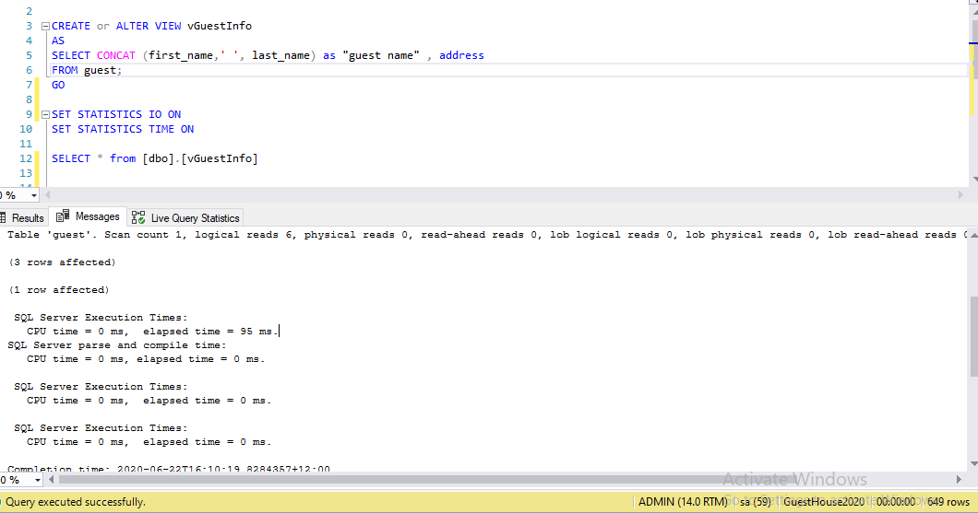

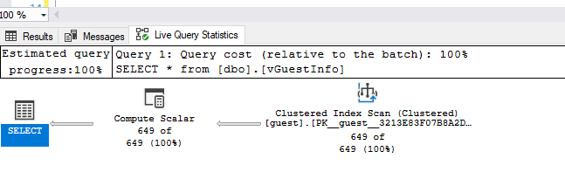

Test 2 : I create nonclustered index lastname as below

Create CREATE NONCLUSTERED INDEX [IX_lastname]

ON guest ([lastname])

Scan count 1, logical reads 6, physical reads 0,

Query scan 649 rows on clustered index

CPU time = 0 ms, elapsed time = 103 ms.

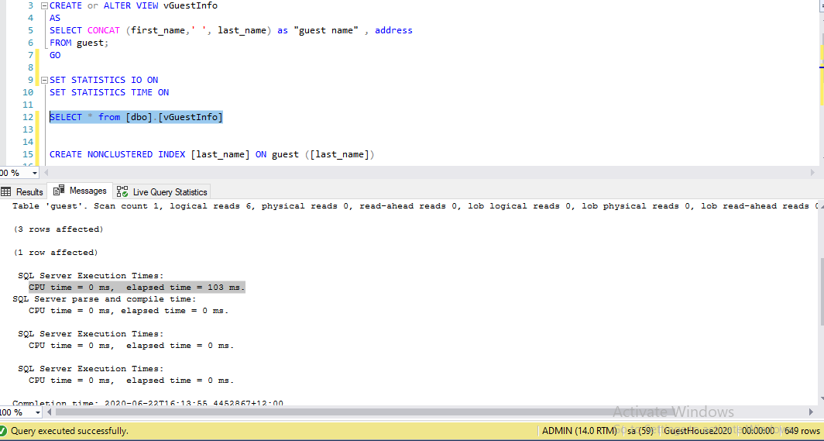

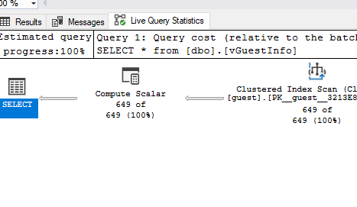

Test 3: I also include first name as Identity  column

DROP INDEX [last_name]ON guest

CREATE NONCLUSTERED INDEX [last_name]

ON guest ([last_name])

INCLUDE([first_name])

Scan count 1, logical reads 6, physical reads 0,

Query scan 649 rows on clustered index

CPU time = 0 ms, elapsed time = 35 ms.

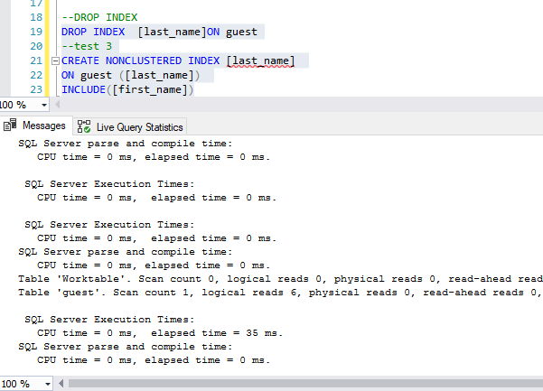

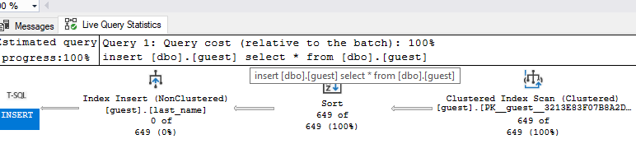

CONCLUSION :

I did 3 optimization as above. All optimization gave same reads, and query cost. In **the 3rd test,** I create Nonclustered index with identity column is both last and first name . This method reduce running time from 95ms to only 35ms. So, this is the most efficient way to run this view.